If you see this information, log in via **Sign In** with the same email and password as for Publons (if you have one), or go via **Institutional Sign In**, where you need to select *Czech Academic Identity Federation eduID.cz*:

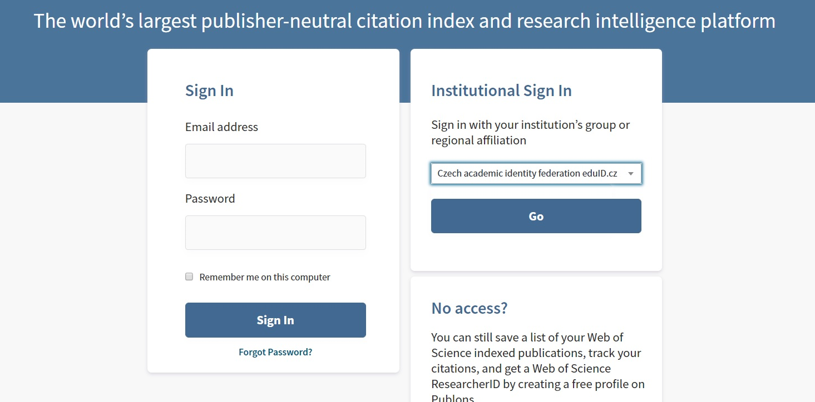

Then choose *Charles University*:

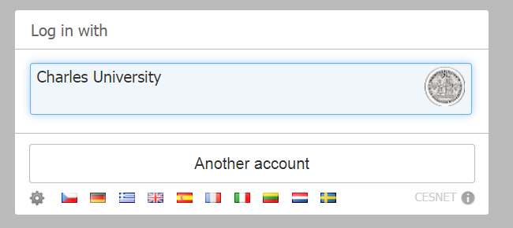

You will then be redirected to login via the *Central Authentication Service (CAS).*